**EEL 4914 - Senior Design I**

**Initial Project and Group Identification Document**

**Divide and Conquer**

**Hybrid Bike**

**Group 26**

Robert Dumont - Electrical Engineering Major

Jared Faulkner - Electrical Engineering Major

Austin Martratt - Electrical Engineering Major

Sponsors: 4F Structural Concrete & Masonry, LLC

**Project Narrative**

In this day and age, most people in metropolitan area commute using bicycles to work, to run errands, or just to travel from point A to point B. Even people use their bikes for exercise and for fun, but one thing that isn’t fun is being fatigue from riding too long. To help solve this issue, what if your bike could run by a motor?

The main motivation for this project was to be able to demonstrate what we have learned in the time that we have been at UCF and apply it to a project. After searching many project ideas, we have concluded that a solar powered bike would be a viable idea that would show our acquired skills and knowledge.

The goals for this project will be several small goals with one main goal: to have a motorized hybrid bike that can be charged via direct charge from a typical American power outlet and also solar energy. How we plan to implement this bike is that there will be two power sources, one battery to power the motor of the bike, and a secondary battery (a lower voltage battery) to power the sensor systems for the bike. The motor subsystem will consist of a motor to rotate one of the bike wheels that will be controlled by a variable speed controller. The sensor subsystem will consist of a microcontroller that will take sensor input from the wheel to measure the speed of the bike. That information will be processed through the microcontroller and displayed on a LCD screen the speed of the bike. The power conversion subsystem will take input from the solar panel and the wall and charge the two batteries accordingly. For charging the secondary battery, the main source will be from the solar panel but we will implement an over charging protector for it. The primary battery will also function as a secondary charging source for the secondary battery in the case that the solar panel is producing a low voltage.

The bike would also act as a standard bike by being able to be ridden normally by peddling but with the addition of having the choice to ride automatically. The Hybrid Bike shall have little cost of energy, would be easy to operate, and will be a more environmentally efficient alternative to other forms of transportation. In addition, we would try to implement other features into the bike that would enhance the usability of the bike as well as further demonstrate our knowledge that we have acquired through our UCF career.

The function of the Hybrid Bike would be to provide a clean and fuel efficient way for people to get around from place to place without having to peddle if desired. The user would also have access to additional features of the bike to make the ride more enjoyable and/or easier.

**Requirement Specifications**

**\* “**The system” refers to the bike and all accessories and/or attachments

* The system shall be no taller than 3.333 ft.
* The system shall be no longer than 6 ft.
* The system shall not weigh more than 125 lbs.
* The system shall contain a bike, battery, solar panels, motor, and sensor control
* The solar panels shall not exceed 8 cubic feet
* The power system will have overcharge protection
* The power system shall have current leakage protection
* The power system shall be capable of delivering at least 24 volts DC
* The secondary battery shall be capable of charge via solar panels and/or wall plug
* The power supply shall be capable of powering multiple sensors and accessories
* The power supply shall be capable of powering the DC motor
* The bicycle shall be able to reach speeds of 12 miles per hour via electrical operation
* The battery shall have a full charge time of at least 12 hours
* The system shall be capable of variable speed operation
* The total cost of the system shall not exceed $1500.
* The bike must be blue (sponsor requirement).

**Market/Engineering Requirements**

Table 1 reflects the direct association between marketing and engineering requirements, whether they correlate or do not correlate and whether the correlation is strong in a positive or negative manner.

**Table 1:** Engineering vs. Marketing Requirements

|  |  |  |  |  |  |  |  |
| --- | --- | --- | --- | --- | --- | --- | --- |
| **Engineering**  **Requirements** | | **Marketing Requirements** | | | | | |
| **Ease**  **Of use** | **High Performance** | **Energy Cost** | **Quality** | **Speed** | **Engineering**  **Target\*** |
| + | + | - | + | + |  |
| **Efficiency** | + | $↓$ | $⇑$ | $$⇑$$ | $$⇑$$ | $$⇑$$ | >70% |
| **Weight** | - | $↓$ | $⇑$ | $↓$ | $⇑$ | $⇑$ | <125lbs |
| **Battery Life** | + | $↓$ | $⇑$ | $$⇑$$ | $⇑$ | $⇑$ | >12 hours |
| **Dimensions** | - | $↓$ | $↑$ | $↓$ | $↓$ | $↓$ | <3.33x6 ft. |
| **Cost** | - | $⇑$ | $⇑$ | $⇑$ | $⇑$ | $⇑$ | <$1500 |

*For Engineering Requirements

$↑$ = Positive correlation

$⇑$ = Strong positive correlation

$↓$ = Negative correlation

$⇓$ = Strong negative correlation

+ = Increases the requirements

- = Decreases the requirements

**Block Diagram**

The block diagram shown in Figure 1 shows the general set-up for the hybrid bike. The section corresponding to each member’s responsibility is filled with the color of that in the legend.

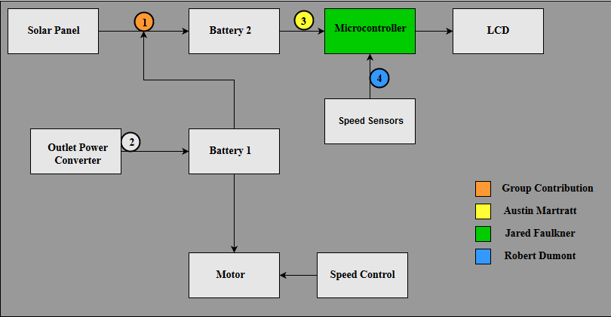

**Figure 1:** Design Flow and Project Responsibilities

1. Power Conversion Subsystem (PCS). This subsystem will convert and control all power flowing from the Battery 1 (Primary) and the solar panel. When the solar panel is not producing a high enough voltage to charge Battery 2 (secondary), then the Battery 1 (primary) will begin to take control of charging Battery 2 (secondary). In each charging path, there will be overcharging protection for Battery 2. This will be a PCB design.
2. This will convert AC 120V 60Hz power source coming from a typical wall outlet to charge the 24V DC Battery 1. This will be a component not design but purchased.
3. If the Battery 2 (secondary) does not match the voltage needed to power the microcontroller, then a power conversion circuit will be necessary here.
4. The speed sensor we are deciding whether to have a speed sensor or a time sensor to measure the speed of the bike.

**Budget**

The prices displayed in Table 2, below are estimations of what we believe each component would cost. Each item is subject to change whether we find a more efficient part or a lower/higher costing part. Because of possible price changes, the total cost may also be subject to change.

**Table 2:** Design Cost

|  |  |  |  |
| --- | --- | --- | --- |
| **Name** | **Quantity** | **Estimated Cost** | **Total** |
| Bicycle | 1 | $150 | $150 |
| Solar Panel (12V) | 2 | $100 | $200 |
| EBike Motor (24V 250W) | 1 | $160 | $160 |
| Battery (12V) | 2 | $125 | $250 |
| AC to 12vDC Converter | 2 | $20 | $40 |
| Charge Regulator | 2 | $12 | $24 |
| PCB | 2 | $50 | $100 |
| Micro-Controller | 1 | $25 | $25 |
| **Total Estimated Cost** | **$1049** | | |

**Project Timeline**

Table 3 portrays the general timeline, which we believe is a rough estimate of when each task or research will be started and completed. Note that some of the tasks displayed in the timeline can be extended or shortened depending on needs of other tasks/research.

**Table 3:** Project Timeline

|  |  |  |  |  |
| --- | --- | --- | --- | --- |
| *Number* | *Task* | *Start* | *End* | *Status* |
| **Senior Design 1** |  |  |  |  |
| 1 | **Idea** | 8/22/2016 | 9/1/2016 | Completed |
| 2 | **Project Selection & Role Assignments** | 8/29/2016 | 9/9/2016 | Completed |
| 3 | **Project Report** |  |  |  |
| 4 | Initial Document – Divide & Conquer | 9/5/2016 | 9/9/2016 | In Progress |
| 5 | Table of Contents | 9/12/2016 | 10/3/2016 | In Progress |
| 6 | First Draft | 9/19/2016 | 10/10/2016 | In Progress |
| 7 | Final Document | 9/5/2016 | 11/26/2016 | In Progress |
| 8 | **Research, Documentation, and Design** |  |  |  |
| 9 | Solar Panel | 9/10/2016 | 9/30/2016 | Researching |
| 10 | DC Motor | 9/10/2016 | 9/30/2016 | Researching |
| 11 | Micro Controller | 9/10/2016 | 9/30/2016 | Researching |
| 12 | PCB Design | 9/30/2016 | 10/23/2016 | Researching |
| 13 | Power Supply | 10/1/2016 | 10/23/2016 | Researching |
| 14 | **Order Parts** | 11/14/2016 | 11/30/2016 |  |
| 15 | **Sensor Testing & Data Collection** | 11/30/2016 | 12/10/2016 |  |
| **Senior Design 2** |  |  |  |  |
| 16 | **Assemble Prototype** | 1/16/2017 | TBD |  |
| 17 | **Testing and Redesign** | TBD | TBD |  |
| 18 | **Finalize Prototype** | TBD | TBD |  |
| 19 | **Peer Report** | TBD | TBD |  |
| 20 | **Final Documentation** | TBD | TBD |  |
| 21 | **Final Presentation** | TBD | TBD |  |